August 2025 Newsletter

**Mayor:**

Roy Schulz

**Council:**

Michael Hale

Margie Jaeger

Pete Martin

Shelly Ausmus

Cheri Currier

Dave Tysz

Dan Thomas

**Clerk/Treasurer:**

Eliza Evans-Teague

**Deputy Clerk:**

Nikki Jensen

**Maintenance**

Steven Thomas

Jeff Latkowski

**Code Enforcement Officer:**

Mike Bogenreif

509-828-2144

tekoacodeenforcement@outlook.com

**Building Inspector:**

Kevin Turnbough

509-714-5148

kturnbough14@gmail.com

**Office Hours:**

8:00 A.M. to

4:00 P.M.

**Council Meetings:**

3rd Monday

6:00 P.M.

Tekoa City Hall Council Chambers

**Phone:**

509-284-3861

**Fax:**

509-284-3590

**Email:**

tekoaclerk

@gmail.com

**Website:**

www.tekoawa.com

|  |  |
| --- | --- |
| August 4 – Tekoa EMS & EMT Training  6:30 P.M. – Ambulance Barn  August 5 – Whitman Co. Hosp. Dist.  6:30 P.M. – City Hall  August 12 – Empire Theatre  5:30 P.M. Empire Theatre  August 18- City Council Meeting  6:00 P.M. – City Hall | August 19 – Parks & Rec  6:00 P.M. – City Hall  August 25 – Tekoa EMT (Board meeting)  6:30 P.M. – Ambulance Barn  August 28 - Food Distribution  8:00-11:00 A.M. – City Hall |

3



*Message from the Mayor—*

Hello citizens, thank you for taking the time in your day to check out the city's newsletter and stay up to date with all that is happening with our various organizations. As summer is in full swing, harvests will be starting, and we should all be aware of the additional traffic and congestion on the roads. Having been on both sides of the situation, I urge everybody to be considerate of the other drivers and be as safe as possible.

As I write this, there are many projects the city is involved in. With Mike Hale's help, the airport is undergoing a major construction upgrade. When done, the runway and taxiway will be resurfaced, and there will be updated LED runway lights and eventually a new fuel pump. A majority of the project is funded by grants and loans supplied by WSDOT and the Port of Whitman. Also, conversation continues with the Port of Whitman about the progress happening at the Industrial Park property on the former Faunce property. As we work through the channels, the Port is taking the lead with the City's approval. At present, we are working with the Water Conservancy Board about the well that the property will require and whether it will have an impact on the City's water supply. The good news is that the well is on the same water source, and the availability of water won't affect the City's needs. Eventually, the property will also have three-phase power and high-speed broadband internet. The Public Works crew has been working on crack sealing the pavement around town to extend its lifespan before a major reconstruction is needed. Presently, we still hope to do sidewalks and a couple of water and sewer projects.

I would like to welcome a new business to downtown. Bee's Thrift Store has been up and running for about a month now, so stop in and look around, and say hi.

Thanks for listening, and we'll talk next month.

Roy

~No matter how many mistakes you make or how slow the progress, you are still way ahead of everyone who isn't trying.

**Tekoa Food Pantry**

Tekoa Food Pantry will distribute commodities on August 28 from 8:00 A.M. to 11:00 A.M.

**Tekoa Parks & Recreation Fun Facts**

Do you love the outdoors, swimming, recreation, and giving back to our community? We are looking for a motivated, passionate, caring, and “willing to roll up your sleeves” commissioner to serve on the Tekoa Parks and Recreation Board. If you are interested, please join us at our next meeting, scheduled for Tuesday, August 19, at 6:00 PM

We have over 70 patrons on Wednesdays, when our neighboring town of Fairfield arrives to enjoy our pool. Thirty kiddos participated in swimming lessons, and water aerobics has been a hit, with as many as 26 participants. Several community members have hosted birthday parties at our local parks and the pool.

**Empire Theatre**

The Library's End-of-Summer-Reading Celebration prize and contest announcements will take place at 5:00 PM, August 15th, followed by the movie “The Lorax” at 5:30 PM. Both concessions and T-shirts will be available for purchase (Theater shirts are $20 & Wheat stalk shirts are only $10).

If you're interested in volunteering for the theater, our meetings are held at the theater on the 2nd Thursday of each month at 5:30 PM. Please join us & learn about the opportunities available.

**Tekoa Library**

* The library will be closed August 4-10.
* Crafter's Circle on Tuesdays at 4 PM, August 12, 19, 26.
* Kid's Club-mosaic bookmark on Wednesday, August 13, drop-in between 1:30-4 PM
* Ripple-Effect Program August 14 at 1:30 PM.
* The end-of-Summer-Reading Celebration on August 15 at 4 PM.
* Adult Book Club on Wednesday, August 20 at 6 PM.
* Storytime starts August 21 at 11:45 AM, every Thursday following.

**Healthy Tekoa**

I hope everyone has fun on National Night Out in Tekoa on August 5th. Thank you to Whitman County Public Health and Banner Bank “Grill Masters” for the yummy food. A big thank you to all the first responders and volunteers who come out to make the evening a success! August 31st is Overdose Awareness Day. Overdose is preventable by learning the harms alcohol, opioids, and other drugs can do; knowing the signs of overdose; and being ready to respond – Call 911, then administer first aid. Find more information at **https://www.overdoseday.com/overdose-prevention/**

Please join us and be part of positive change in our community! Meetings resume Tuesday, September 9, at 9 AM at the Tekoa School District Boardroom & Zoom—email **jolson@tekoasd.org** for the meeting link.

**Chamber of Commerce**

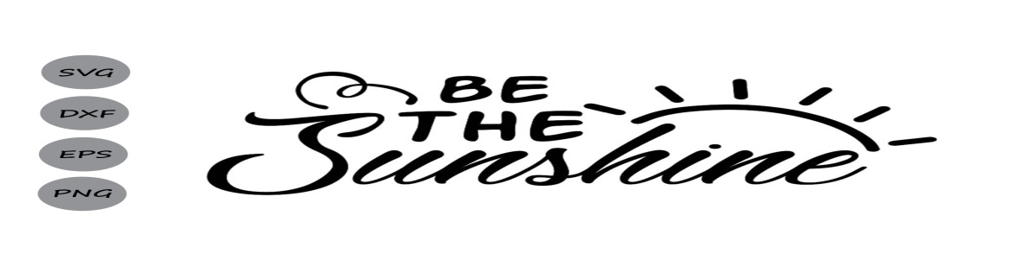We hope folks were able to unload some old stuff or find a special treasure at the Annual Community Yard Sale Day.  Thanks for a great day!